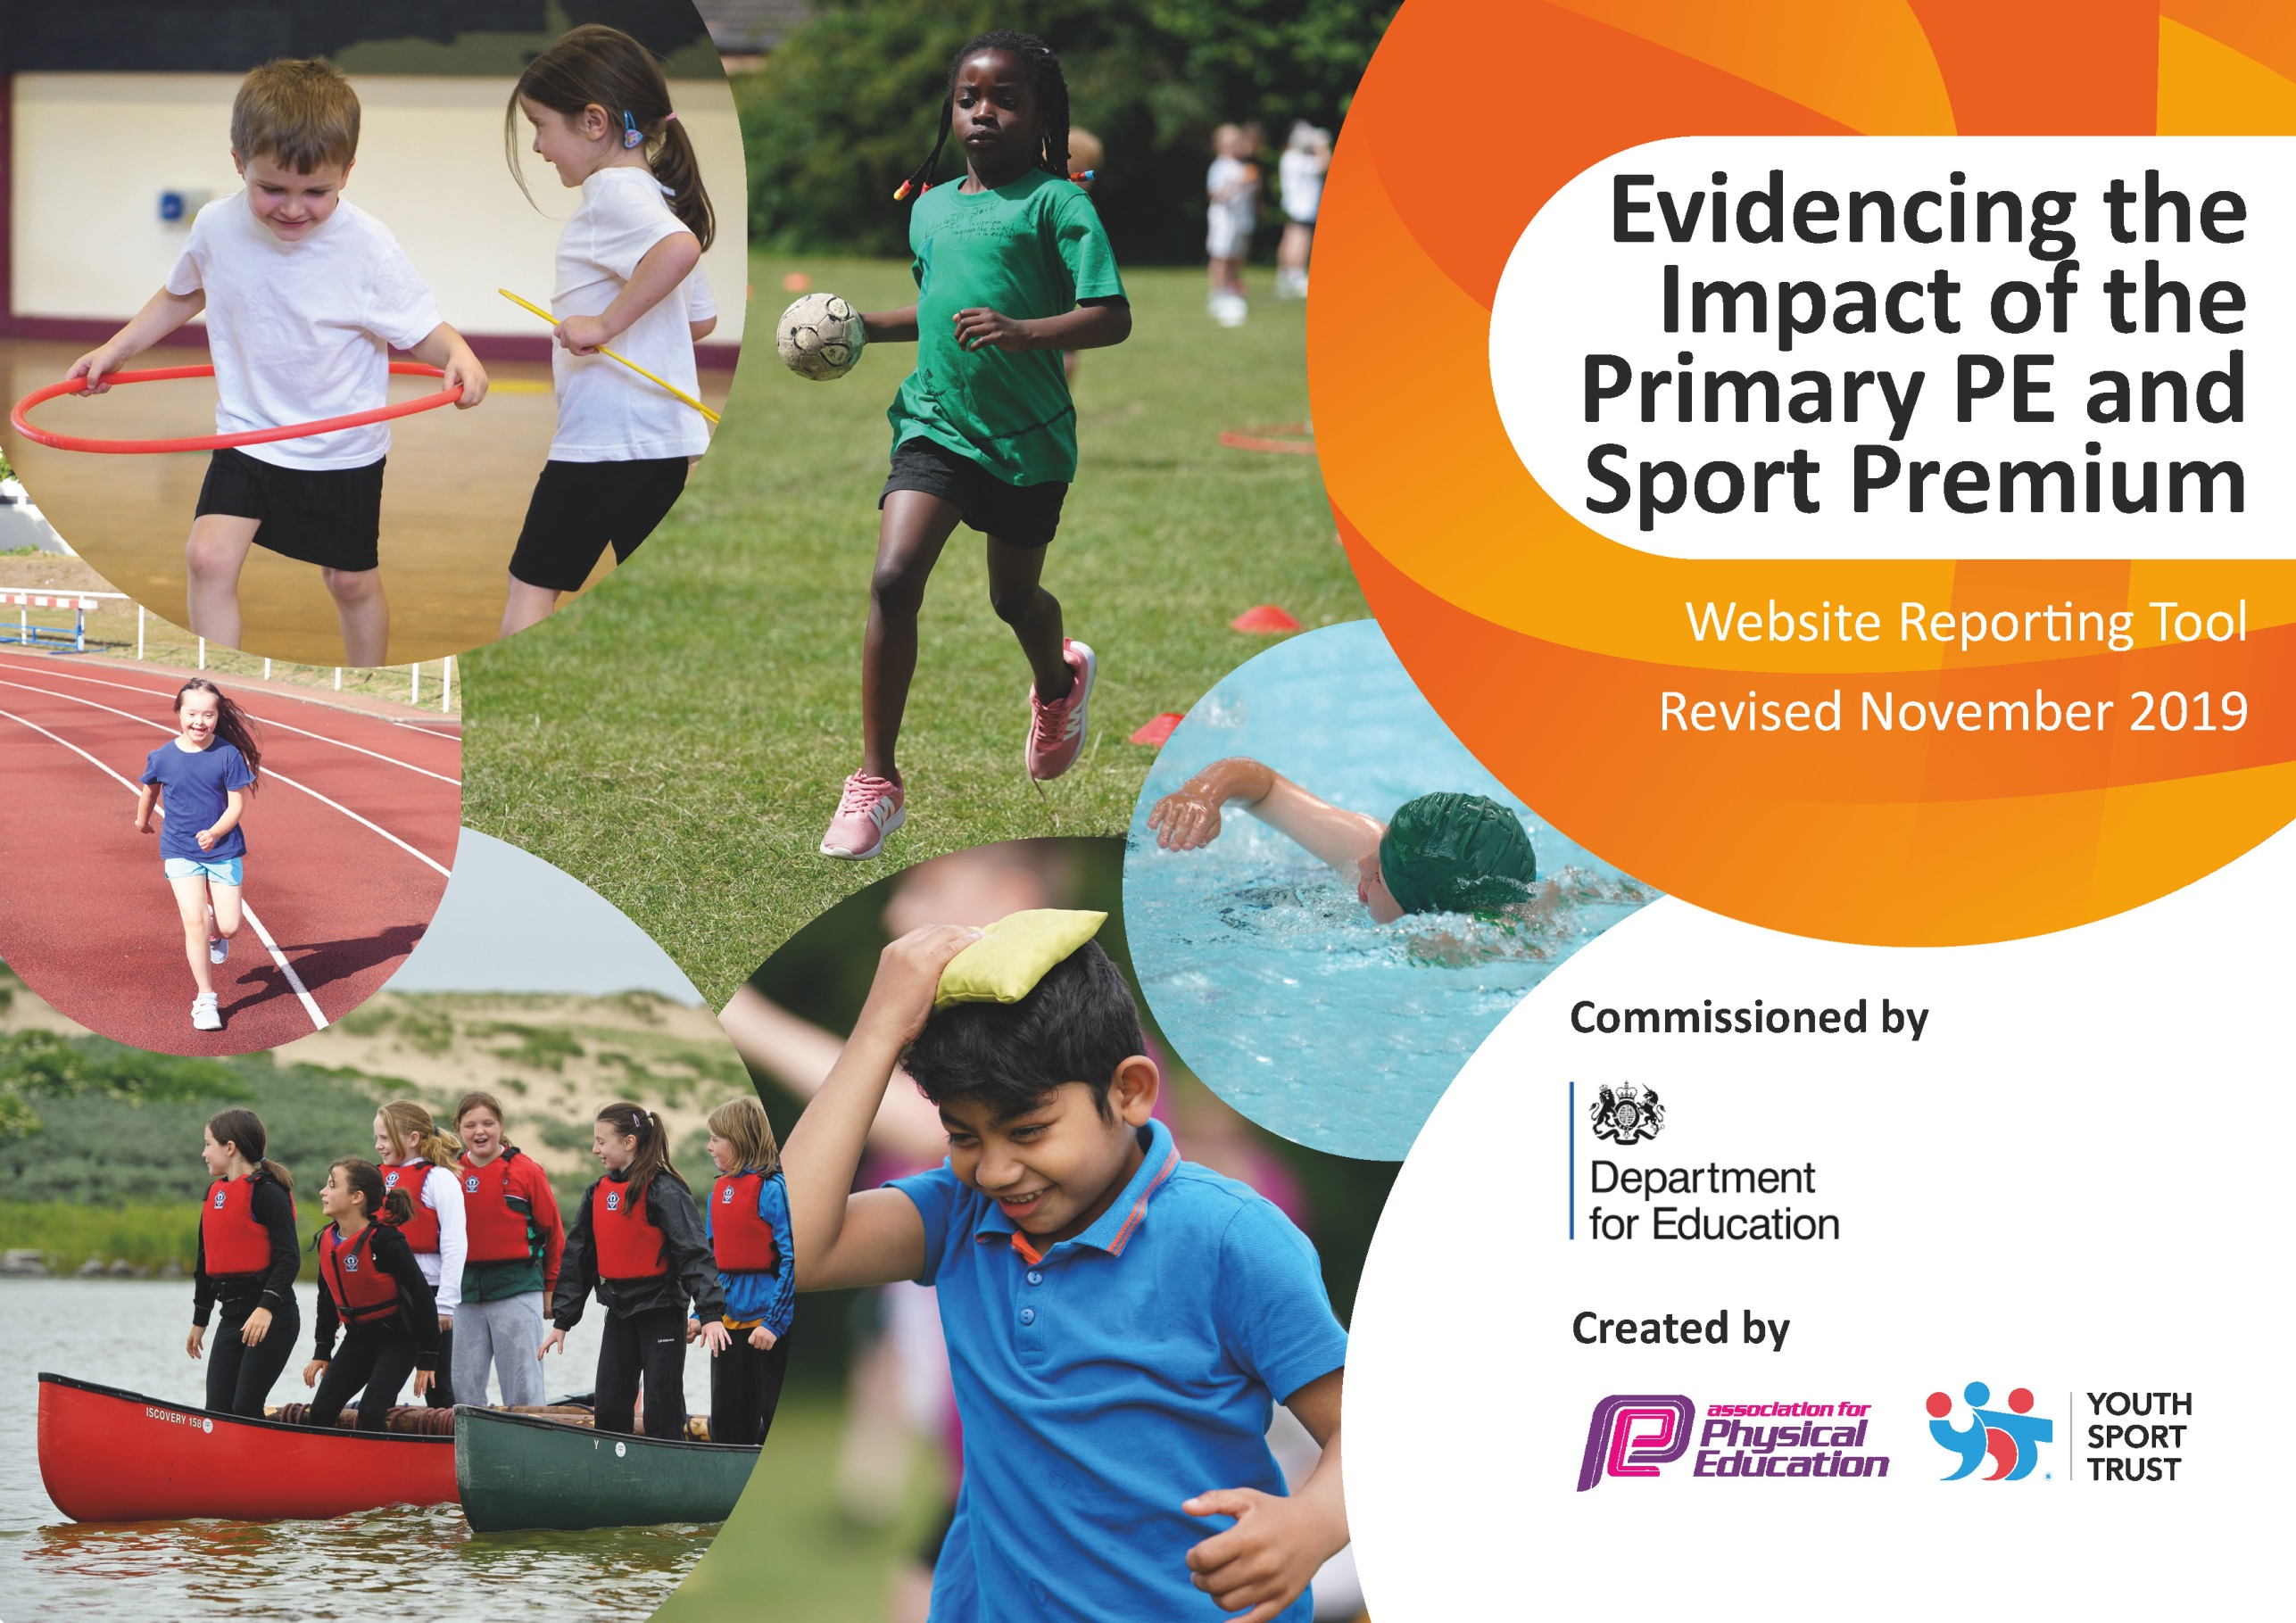
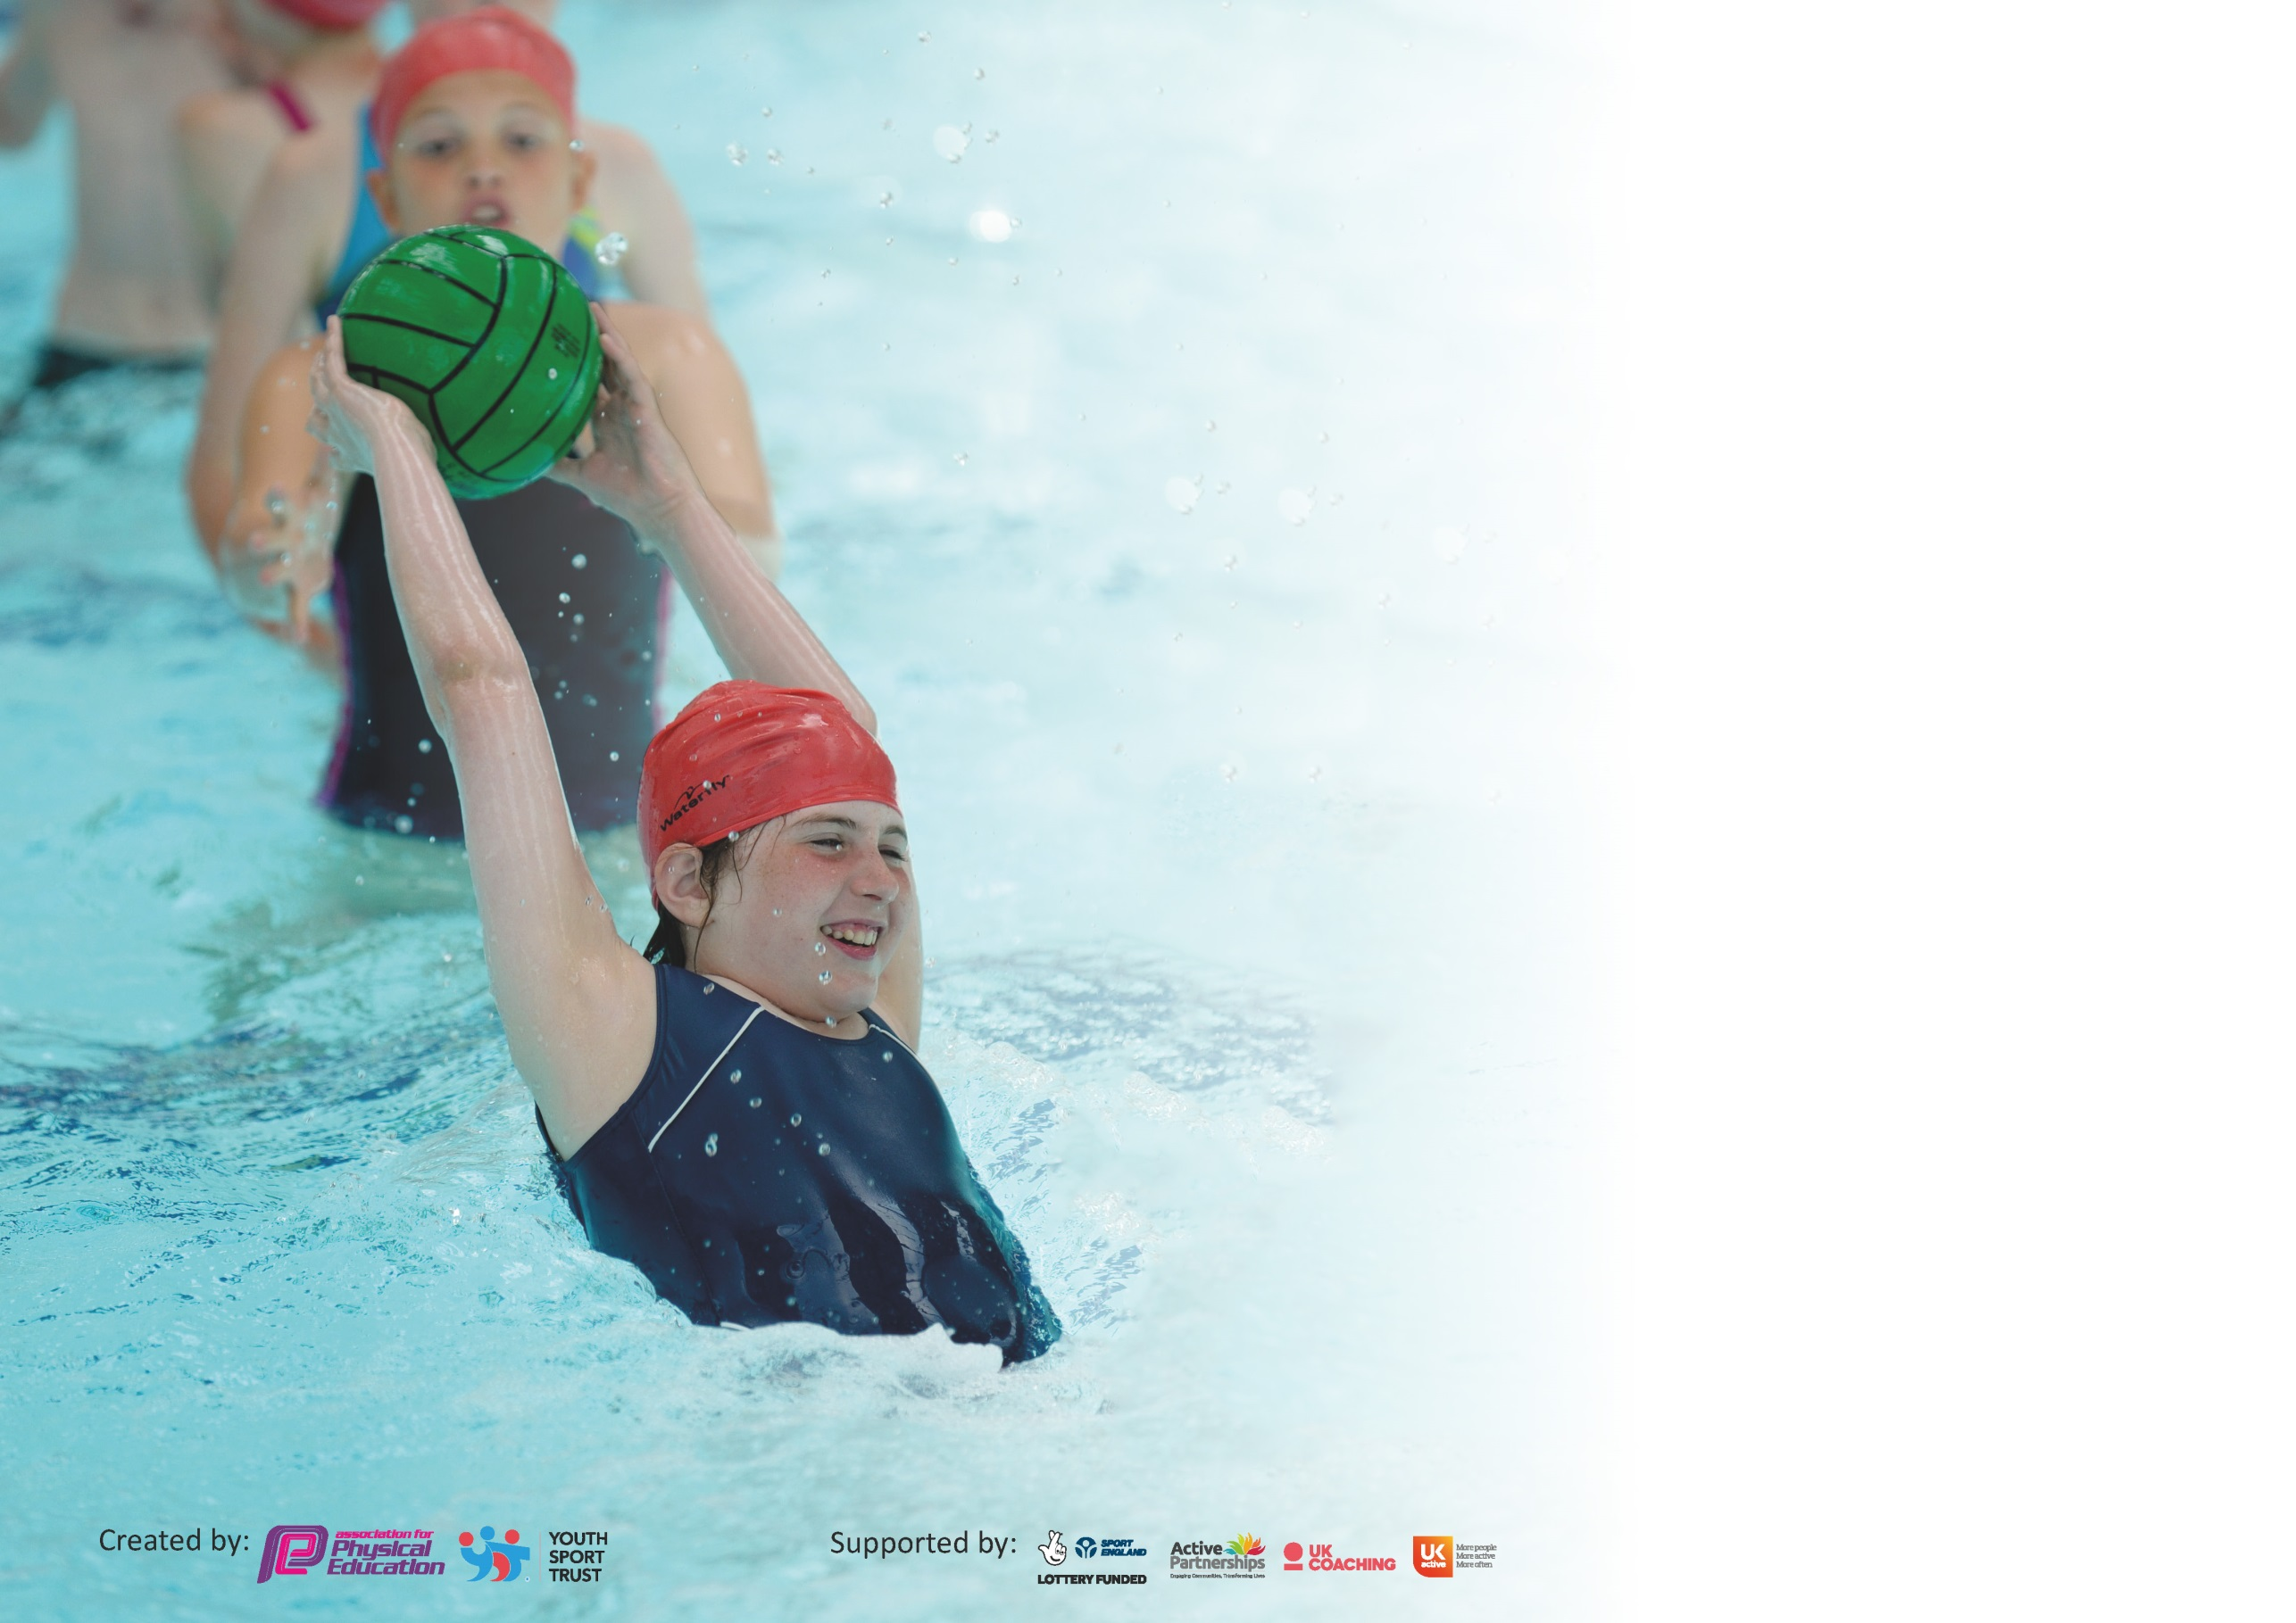

It is important that your grant is used effectively and based on school need. The Education Inspection Framework (Ofsted 2019 p64) makes clear there will be a focus on ‘whether leaders and those responsible for governors all understand their respective roles and perform these in a way that enhances the effectiveness of the school’.

Under the Quality of Education criteria (p41) inspectors consider the extent to which schools can articulate their curriculum (INTENT), construct their curriculum (IMPLEMENTATION) and demonstrate the outcomes which result (IMPACT).

To assist schools with common transferable language this template has been developed to utilise the same three headings which should make your plans easily transferable between working documents.

Schools must use the funding to make additional and sustainable improvements to the quality of Physical Education, School Sport and Physical Activity (PESSPA) they offer. This means that you should
use the Primary PE and Sport Premium to:

- Develop or add to the PESSPA activities that your school already offer
- Build capacity and capability within the school to ensure that improvements made now will benefit pupils joining the school in future years

Please visit gov.uk for the revised DfE guidance including the 5 key indicators across which schools should demonstrate an improvement. This document will help you to review your provision and to report your spend. DfE encourages schools to use this template as an effective way of meeting the reporting requirements of the Primary PE and Sport Premium.

We recommend you start by reflecting on the impact of current provision and reviewing the previous spend.

Schools are required to publish details of how they spend this funding as well as on the impact it has on pupils’ PE and sport participation and attainment by the end of the summer term or by 31st July 2020 at the latest.

We recommend regularly updating the table and publishing it on your website throughout the year. This evidences your ongoing self-evaluation of how you are using the funding to secure maximum, sustainable impact. Final copy must be posted on your website by the end of the academic year and no later than the 31st July 2020. To see an example of how to complete the table please click HERE.

Support for review and reflection - considering the 5 key indicators from DfE, what development needs are a priority for your setting and your pupils now and why? Use the space below to reflect on previous spend and key achievements and areas for development.

Key achievements to date until July 2019: | Areas for further improvement and baseline evidence of need:
Specialist coaches to teach new sports  PE Teaching Assistant  Year 6’s swimming 25m well above average (in spite of Covid-19)  Attending many competitions with more than one team  Attending new competitions  Further developed staff CPD in sport.  Promoting female participation in sport and breaking down gender norms including many female students leading sporting activities at playtimes and lunchtimes.  High percentages of FSM children attending clubs and competitions  Sport assisting the wider curriculum and school day  Sensory circuits set up for key learners  Sport used to develop confidence within our most vulnerable children | To further progress the sports covered at school  To further increase FSM participation in clubs and competitions To continue sensory circuits for our learners who need it.  To use sport as a restorative catalyst for our learners.  To further increase staff knowledge in sport through our CPD programme.  To further use sport to assist mental health and wellbeing of our students.  To continue to break down barriers for participation e.g. DPP, SEN.  To help increase attainment throughout the school through sport.  To increase the activity level of our student to combat lockdown sedentary behaviour.

Meeting national curriculum requirements for swimming and water safety.
What percentage of your current Year 6 cohort swim competently, confidently and proficiently over a distance of at least 25 metres?  N.B. Even though your pupils may swim in another year please report on their attainment on leaving  primary school at the end of the summer term 2020. | 81%
What percentage of your current Year 6 cohort use a range of strokes effectively [for example, front crawl, backstroke and breaststroke]? | 81%
What percentage of your current Year 6 cohort perform safe self-rescue in different water-based situations? | 95%
Schools can choose to use the Primary PE and Sport Premium to provide additional provision for swimming but this must be for activity over and above the national curriculum requirements. Have you used it in this way? | Yes/No

Action Plan and Budget Tracking
Capture your intended annual spend against the 5 key indicators. Clarify the success criteria and evidence of impact that you intend to measure to evaluate for pupils today and for the future.

Academic Year: 2018/19 | Total fund allocated: £ | Date Updated:
Key indicator 1: The engagement of all pupils in regular physical activity – Chief Medical Officer guidelines recommend that primary school pupils undertake at least 30 minutes of physical activity a day in school |  |  |  | Percentage of total allocation:
 |  |  |  | %
Intent | Implementation |  | Impact
Your school focus should be clear what you want the pupils to know and be able to do and about  what they need to learn and to  consolidate through practice: | Make sure your actions to achieve are linked to your intentions: | Funding allocated: | Evidence of impact: what do pupils now know and what can they now do? What has changed?: | Sustainability and suggested next steps:
To increase the amount of aerobic exercise our children undertake in school. | Daily Mile  P.E Teaching Assistant organising games Lunchtime and Break time  Additional Sports coaches and P.E resources have been purchased. | £0  £9,654  £1,950 | Daily mile is completed every day by EYFS, KS1 and KS2. Teachers encourage and join in.  Impact – children more active, children running outside of school, children have another incentive to be active at school.  Our P.E Assistant runs and sets up numerous games and activities on the playgrounds.  Setting up of a competition point system so the children have competition within the skills and activities. This has also been used to “level the playing field” between our higher ability and Lower ability increasing self esteem and confidence in our children.  Our School Sports Ambassadors also run games and activities under the supervision of our PE  Assistant.  Children who may struggle to engage at playtimes and lunchtimes have sensory circuit sessions in the morning/early afternoon or have some activity time in the afternoon. This allows us to suit the needs of the child and allow that child to be ready for home time or be ready to learn in the morning/afternoon.  Breakfast club sports provision has been provided which has allowed many children to receive further quality sports and activity provision before school.  Running tournaments for different year groups in football.  Equipment for playtimes has been bought so the children can access games that the playground markings have  intended.  Coaches have also been brought in to provide further extracurricular provision in sports and activities such as Golf, Hockey and Inclusive Games. | To track the progress of the distances that the children can cover during the daily mile session.  Run around the world/country. What distance can be covered and logged.  This will run next year – to develop this we shall run more activities. Our P.E assistant will provide CPD for our Apprentice.  To further develop this in to a termly reported points competition with a trophy for the winning children/sports house.  Our School Sports Ambassadors have left a legacy that our new ambassadors will follow.  These will continue and progressed further next year with our new P.E apprentice.  This provision will continue next year.  To apply this format to more sports and to keep it in line with our curriculum.  To sustain and replace the equipment we have while providing more diverse equipment for playtimes.  To further provide extra coaches for our learners.
Key indicator 2: The profile of PESSPA being raised across the school as a tool for whole school improvement |  |  |  | Percentage of total allocation:
 |  |  |  | %
Intent | Implementation |  | Impact
Your school focus should be clear what you want the pupils to know and be able to do and about  what they need to learn and to  consolidate through practice: | Make sure your actions to achieve are linked to your intentions: | Funding allocated: | Evidence of impact: what do pupils now know and what can they now do? What has changed?: | Sustainability and suggested next steps:
To use P.E, games and swimming to develop pupil wellbeing.  To use P.E, games and swimming to ensure children make progress in other areas curriculum areas such as PSHE and Maths. | Daily Mile-Wellbeing Multiplication  (P.E Apprentice)  Staff CPD  PE Assistant – Behaviour, Inclusivity, Mental Health and Wellbeing.  Breaking stereotypes within sport  Supporting gifted females in our school.  School Sports ambassadors – self- esteem, confidence | £ Already allocated section 1  £ Already allocated in section 1  £0  Already allocated section 1  £0  £35  £0 | Children complete the daily mile and as a result are more energised when coming in to the classroom to start their work. It is also a time for them to focus on nothing else but running. We have also incorporated our times tables into our daily mile and the children perform an athletic movement e.g star jumps while calling out their times tables.  All teaching staff had CPD training in a sport of their choice which they then ran a club in. this allowed us to provide more clubs and also allowed our classroom teaching staff to provide clubs of a higher quality.  Our PE assistant has supported children with behavioural and additional needs.  This has then had a direct impact on those children in class and around the school.  Children have also been further encouraged to take part in activities at break times and Lunch times, this has then  increased their confidence and self-esteem as well as allowing them to have the opportunity in different areas of sport.  This includes assisting in promoting the breaking down of gender stereotypes in sport by further celebrating everyone’s successes in sport .  This year we have also had many girls running competitions and activities at play and lunchtimes. This has provided many strong and positive role models for our younger female learners.  We also encouraged/funded a gifted Netball player and attended the try-outs for County and gained a place. This was then celebrated during a collective worship assembly.  At our school we have sports ambassadors that work with our PE teacher and PE Assistant.  The children are supported in leading games at playtimes and lunch times, officiating and helping run sports day. This helps with our children’s self-esteem and confidence. | This will continue next year and we shall continue to track the children’s progress.  We are also looking to answer multiplication questions as well as reciting them during.  As last year staff will use their knowledge to provide these clubs again as well as gaining confidence in or learning new sports in their continued CPD.  We will look to use our TA to provide CPD and training for our new Apprentice to further develop and provide this provision.  This will provide physical interventions and 1:1/small group work. This includes conflict resolution and resilience all based around sport.  Our TA and apprentice will be able to work collaboratively with more children.  We work to continue to provide equal opportunities throughout our school and even opportunities that are exclusive to allow use to break stereotypical norms.  We will continue to look for opportunities for all of our learners to excel in what they enjoy.  We will build on our sports ambassador provision allowing them to provide more sports and games and also providing a buddy system for younger children.

Key indicator 3: Increased confidence, knowledge and skills of all staff in teaching PE and sport |  |  |  | Percentage of total allocation:
 |  |  |  | %
Intent | Implementation |  | Impact
Your school focus should be clear | Make sure your actions to | Funding | Evidence of impact: what do | Sustainability and suggested
what you want the pupils to know | achieve are linked to your | allocated: | pupils now know and what | next steps:
and be able to do and about | intentions: |  | can they now do? What has
what they need to learn and to |  |  | changed?:
consolidate through practice:
To upskill teachers in teaching different aspects of P.E and Games.  To allow teachers to inform the areas of CPD they require.  To ensure teachers are not deskilled due to us having a full time P.E teacher.  To ensure of P.E lead has the knowledge and skills to ensure excellent outcomes in P.E. | CPD provision and clubs to upskill teachers  CPD for P.E Lead  CPD for PE assistant | 0  Already allocated Section 2  £289  £ Already allocated Section 1 | As mentioned above.  The upskilling of teachers has also had an impact on the teaching and learning of our EYFS children as they have a PE session with their class teacher and the CPD sessions that they have attend have helped further the quality of these.  The P.E Lead has attended online conferences and webinars for P.E this year and as a result has then brought them back and planned to or has implemented them within the school. This has also had an impact on what P.E will look like under Covid-19 guidance.  Our P.E lead has also attended CPD training on Net and Wall games as well as Outdoor Adventurous activities. This has allowed them to develop and progress our curriculum and ensure that our learners are getting the diet that they require and the best deal possible.  Our PE assistant has also attended the conference/webinar that our PE lead has to further their confidence, knowledge and skill. | Our CPD programme to upskill class teachers in sport will run again and the teacher will learn about a new sport and gain confidence in that. This will then offer more sport to our pupils.  Our P.E lead and new P.E apprentice will attend conferences again next year to gain the latest insight and knowledge, to further provide excellent opportunities for our learners.  These courses have allowed further informed planning of our curriculum and thus affords our learners a better P.E curriculum.  Our P.E apprentice will also attend training that will allow them to implement the most up to date learning.
Key indicator 4: Broader experience of a range of sports and activities offered to all pupils |  |  |  | Percentage of total allocation:
 |  |  |  | %
Intent | Implementation |  | Impact
Your school focus should be clear | Make sure your actions to | Funding | Evidence of impact: what do | Sustainability and suggested
what you want the pupils to know | achieve are linked to your | allocated: | pupils now know and what | next steps:
and be able to do and about | intentions: |  | can they now do? What has
what they need to learn and to |  |  | changed?:
consolidate through practice:
To ensure children get to try a wide range of sporting activities.  To ensure that all children are able to understand and complete the basics of a wide range sports and activities.  To challenge all children at all levels of ability. | Clubs to upskill teachers  Additional clubs provided by specialists  P.E Assistant  P.E leader | £0 Already allocated Section 1  £0 Already allocated Section 1  £0  Already allocated Section 1  £3,603 | The CPD programme to upskill teachers has allowed us to provide clubs such as Netball, Lacrosse, Archery, Circuit Training and Outdoor Adventurous Activities, all of which the children have benefitted from.  This year we have looked to provide further clubs taught by specialists and as a result we have been able to provide further clubs to our already extensive extracurricular provision and at a high level. These additional extracurricular clubs have all been offered for free to all of our children.  The P.E Assistant has allowed us to provide 5 further sports clubs a week as well as helping and supporting in P.E lessons.  The P.E lead organises our extracurricular club provision or which we have over 20 clubs a week per term running for a total of 30 weeks. Approximately 15 of which are Sports Clubs.  He also makes sure that we have high quality teaching and learning through out of P.E curriculum as well as facilitating the provision at break and lunch times and the CPD that the classroom staff need to progress. | Further CPD training for teachers that will mean more sports being offered.  Clubs will run again for sports ran by specialists in their sport. We will look for further avenues to increase this.  Our P.E assistant has been employed as a TA and so will be able to offer this provision and take on further responsibilities. We have also planned to take on a P.E apprentice and so more clubs could be provided.  Our PE lead will continue to provide and lead this club provision and look for more ways to provide more sports opportunities.

Key indicator 5: Increased participation in competitive sport |  |  |  | Percentage of total allocation:
 |  |  |  | %
Intent | Implementation |  | Impact
Your school focus should be clear | Make sure your actions to | Funding | Evidence of impact: what do | Sustainability and suggested
what you want the pupils to know | achieve are linked to your | allocated: | pupils now know and what | next steps:
and be able to do and about | intentions: |  | can they now do? What has
what they need to learn and to |  |  | changed?:
consolidate through practice:
To increase the number of children who attend competitive sporting events. | Enable PE led to take children to more competitive events  Transport  Inter school competitions (PE TA and PE Lead)  SSP membership to enter competitions | £1,146  £0  Funding already allocated Section 1  £2,395 | This year we have attended many competitions with many children.  Amongst these we have:  Taken 75 children represent our school at the Cross county event. Where we came first the Year5/6 Girls, second in the Year 5/6 Boys, second in the Year 3/4 girls and 3rd in the year 3/ 4 boys.  We attended Girls only football with 2 teams.  We attended the indoor athletics for the first time.  We attended the area swimming competition as well as the Dance.  We also won the area Football and Netball competitions.  These were all attended pre-lockdown. | We shall attend at least the same amount of competitions and look to attend competitions that are linked to the specialist coaches to further our attendance at competitions.  We will also provide more opportunities to further increase our percentage of FSM children attending clubs and competitions.

Signed off by
Head Teacher: | Andrew Smith
Date: | 31/07/20
Subject Leader: | D. Toothill
Date: | 31/07/20
Governor: | Full GB Meeting
Date: | September 2020

